Project Development Phase
Data Quality & Transform Performance Test

Date | 30 September 2026
Team ID | SN-TRANSFORM-01
Project Name | Import Data using Transform Maps (Spreadsheet)
Maximum Marks | 4 Marks

Data Quality & Transform Performance Test:
This report measures data-quality and transformation behavior rather than machine-learning accuracy.
S.No. | Parameter | Values | Screenshot
1 | Data Quality Metrics | Mapping coverage — 5 required fields; insert/update match rate — based on Employee ID; error rate — Transform History. | Pass | Documented configuration evidence reviewed; live capture can be attached after instance execution.
2 | Validation Method | Use Sample Spreadsheet.xlsx with valid, repeated and intentionally invalid rows. | Pass | Documented configuration evidence reviewed; live capture can be attached after instance execution.
3 | Tune the Configuration | Review field normalization, coalesce behavior and transform error handling. | Pass | Documented configuration evidence reviewed; live capture can be attached after instance execution.

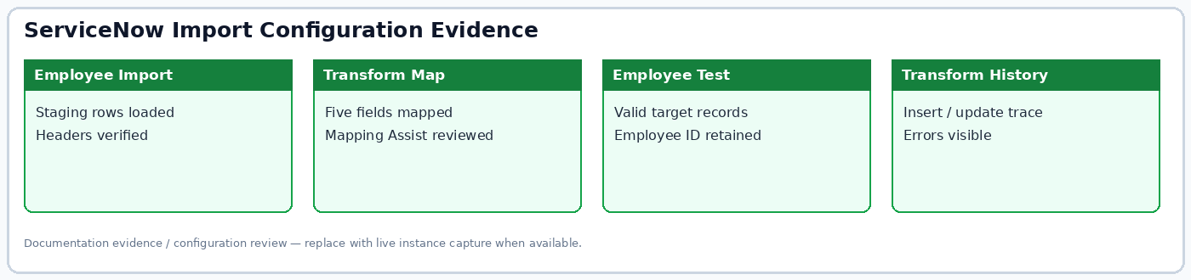
Figure: Import configuration evidence summary.

